Thomas D Heberle-b18081925-d07122013-EriePA
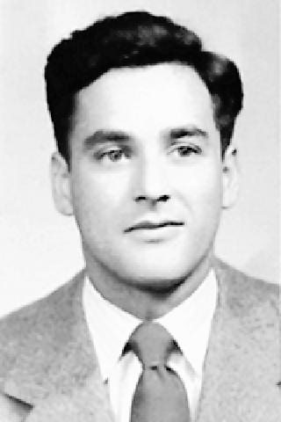
Thomas D. Heberle, age 88, a resident of Presque Isle Rehabilitation and Nursing for many years, died Saturday morning, December 7, 2013 at Millcreek Community Hospital following an extended illness. A resident of Erie all of his life, he was born August 18, 1925, a son of the late Joseph J. and Lillian I. McGrorey Heberle.
Thomas was a 1943 graduate of Academy High School and went on to earn a B.S. in Liberal Arts from Gannon College. He proudly served his country in the United States Air Force during the Korean War. He worked as an Institutional Salesman with Jacob Haller for 25 , and most recently worked in real estate sales with Hagman Realtors for eight years before retiring in 1997. He was a member of St. Luke Catholic Church and the Siebenbuerger Club. He enjoyed camping and boating with his wife, Lois, and also enjoyed hunting, fishing, and golfing.
In addition to his parents he was preceded in death by one son, Timothy Heberle and one brother, John J. Heberle.
Survivors include his wife of 63 years, Lois M. Holtz Heberle; one daughter, Nancy Ohmer and her husband David of Erie; two sons, David Heberle and his wife Marianna, and Mark Heberle and his wife Kathleen, all of Erie; five grandchildren, Marta, Jessica, and Kasia Heberle, Laura Garrison and her husband Justin, and John Ohmer; and many dear, lifelong friends.

